**Apache Maven Plugin For TIBCO**

* Maven plugin for TIBCO Business Works project. The aim of this plugin is to provide tools to validate build ear and generate xml configuration file for tibco business works project. It also allows you to deploy tour project in remote server using SSH.

Steps for Installation:-

* Step1: Download maven binaries.

<http://maven.apache.org/download.cgi>

* Step2: unzip the binary file and keep it in a drive.
* Step3: Download and Install Java if not installed already.

<http://www.oracle.com/technetwork/java/javase/downloads/index.html>

* Step 4: Set the path under Environmental variable. Add below lines under system variables.

Variable Value

M2_HOME Path of the maven binary Home

MAVEN_HOME Path of the maven binary Home

Path %M2_HOME%\bin

* Step 5: Go to C:\user\username/id and type

C:\user\username :> mvn -version

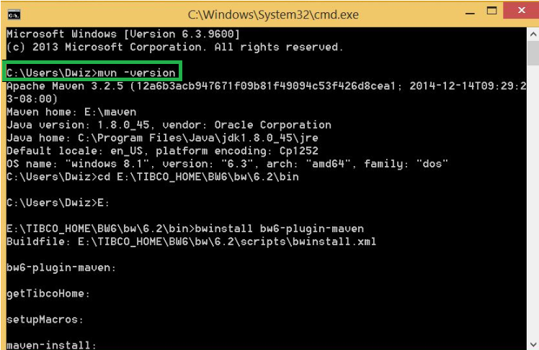

* Step6: Install maven plugin for TIBCO. Go to TIBCO bw6 bin directory and run the below command.

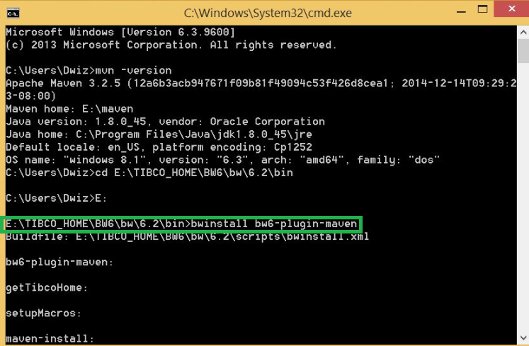

* Step 7: Screenshot of maven plugin installation start.

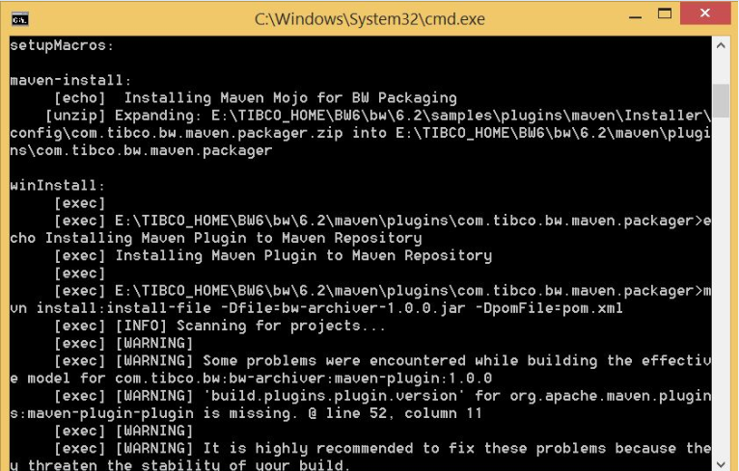

* Step 8: Once installation is done final screenshot will look similar to the below screenshot.

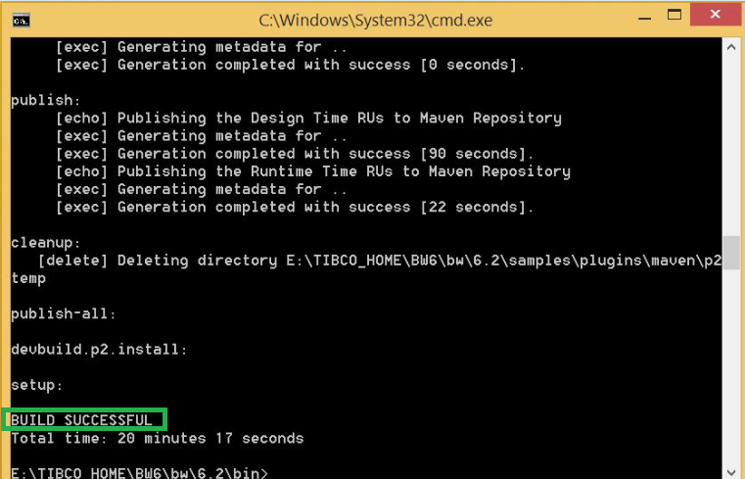

* Step 9: Now re-launch the business studio and select a BW Project, you can see in the context menu a new option that says “Generate POM”, as below

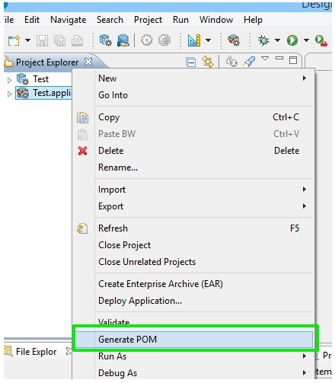

* Step 10: After doing the POM generation process, the BW Application icon changes and it looks a little M in the left-upper corner. This identifies that which projects are using maven and which are not. The pom.xml file generate as the root file for any Maven development.

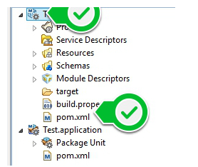

Do 🡪 mvn clean install -U



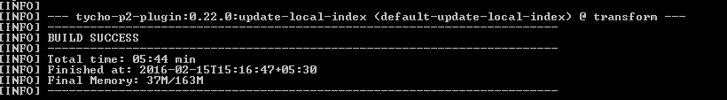

Goto folder where pom.xml is created and in cmd type mvn package

* mvn package

This creates ear for the current application inside target folder

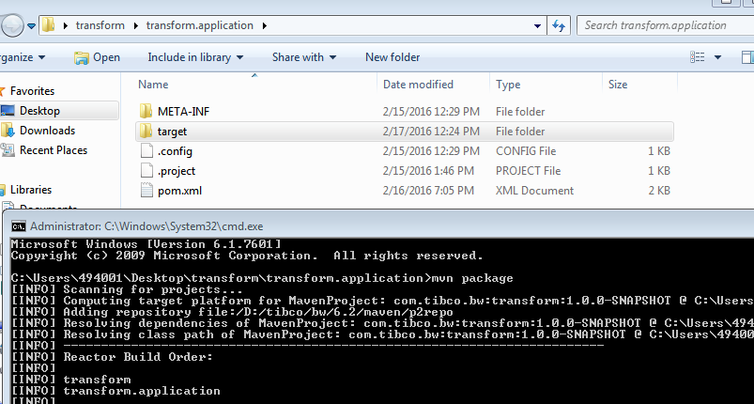

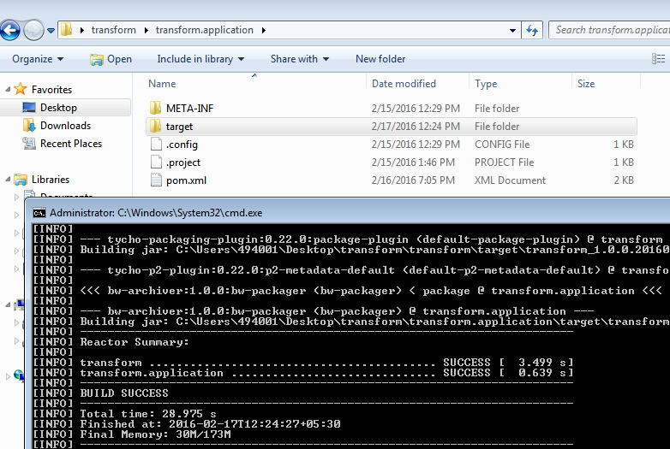

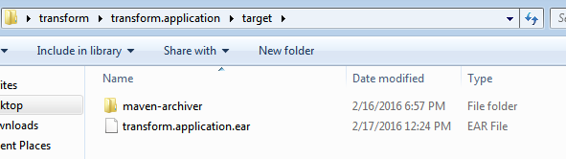

Goto folder where pom.xml is created and in cmd type mvn install

* mvn install

This command will build & deploy the application in the domain, Appspace & Appnode mentioned in the pom.xml

